**Create custom script(command) as system commands**

We have a commands in linux like ls, cd, pwd…

Like that now I want to create a custom command and convert this as a system command.

For example I want know free memory in the system with one command.

Generally to know free memory we use the command free

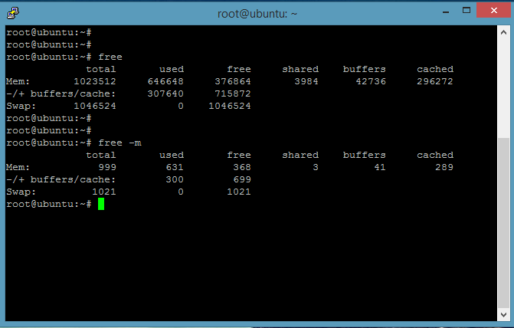

**This is the free memory in my system**

To get this free memory size we can use custom command(custom command means defined by us )

free -m | awk 'NR==2 {print $4, "MB"}'

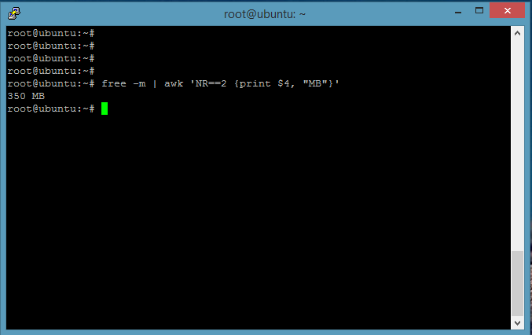

Now I am going to create a shell file with this command,

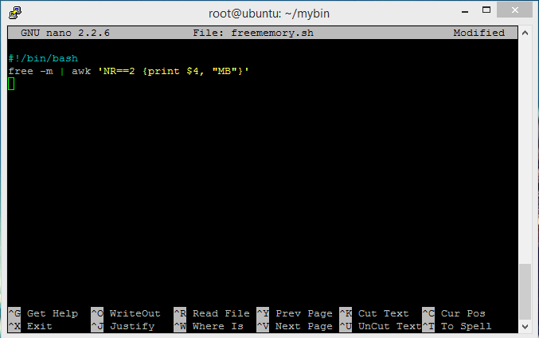

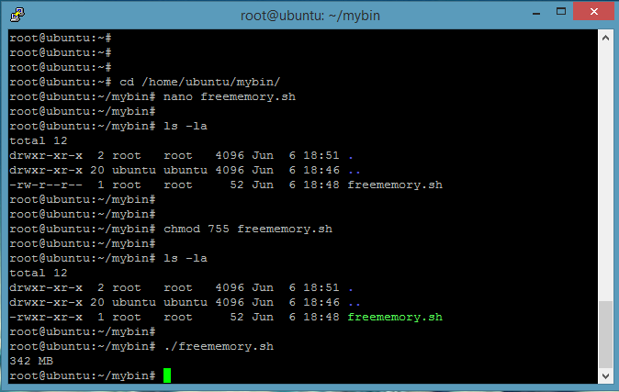

Here I created a script file by usingthis script we can get free memory directly…

We can remove .sh extention also

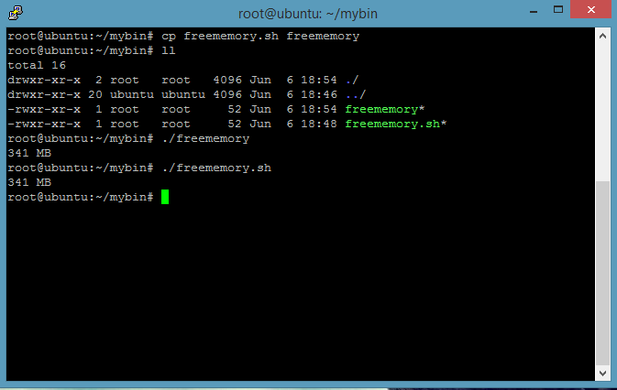

Actually my goal is create system command, system commands we can use any where in the system like cd, pwd, ls,mv,cp..

But now this command we can’t use like that for that we need to go file location

And for system commands no need to use **./**

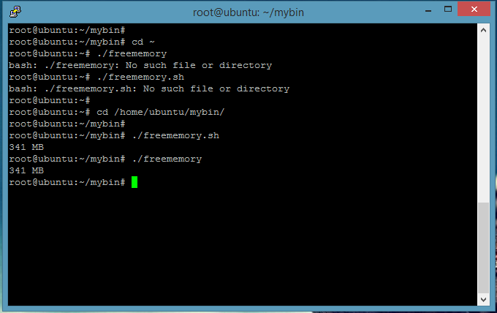

For that we have 2 options

1. Check the system commands path and copy file into that location.

See below figure,

First checked the commands path and move my file into one of that path (/bin)

And run that command from different location, command working as a system command.

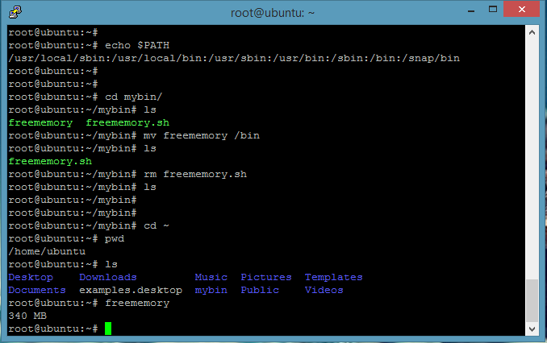

1. Add file path into the system commands path

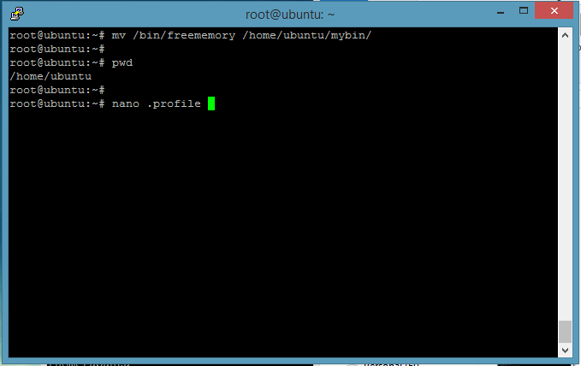

Add file path (/home/ubuntu/mybin) into .profile fie

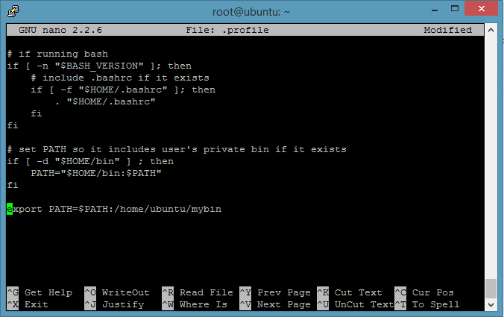

After that run **source .profile** command

And check the path

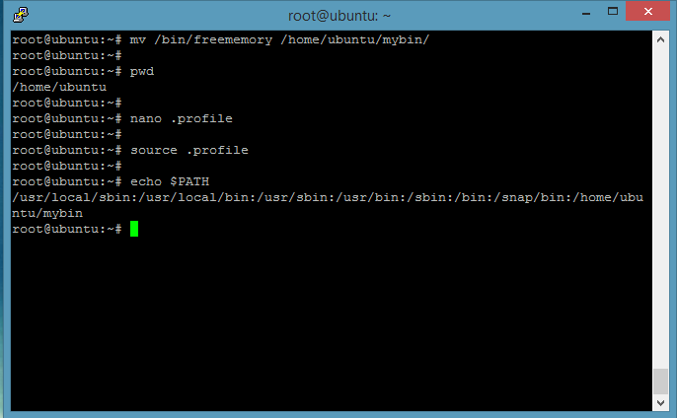

See custom path added into the system path

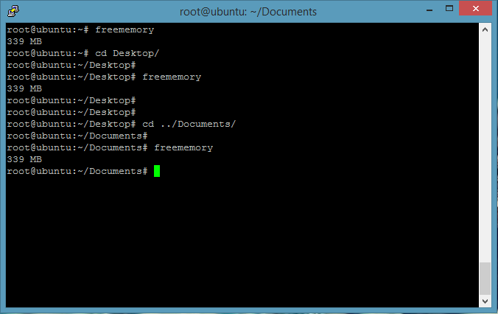

Our Command working in different locations as a system command.